**Data Mining – Assignment 3**

**薛劭杰 1930026143**

Q1.

(a)

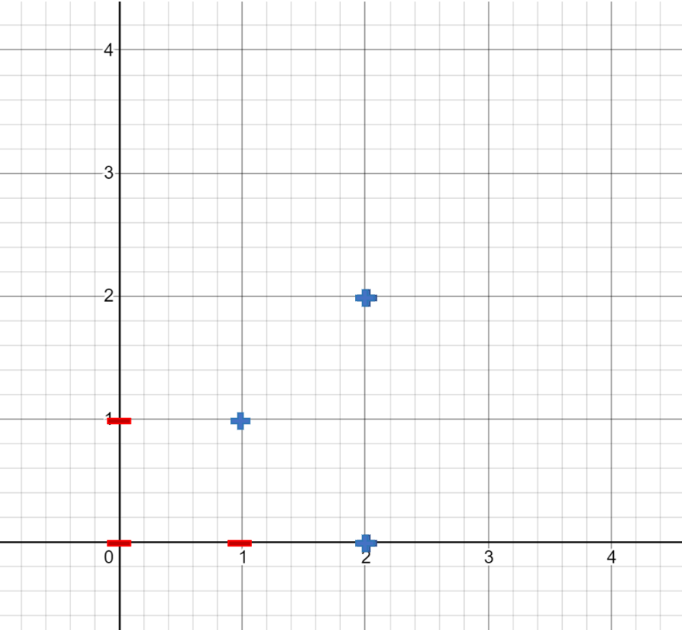

(2)

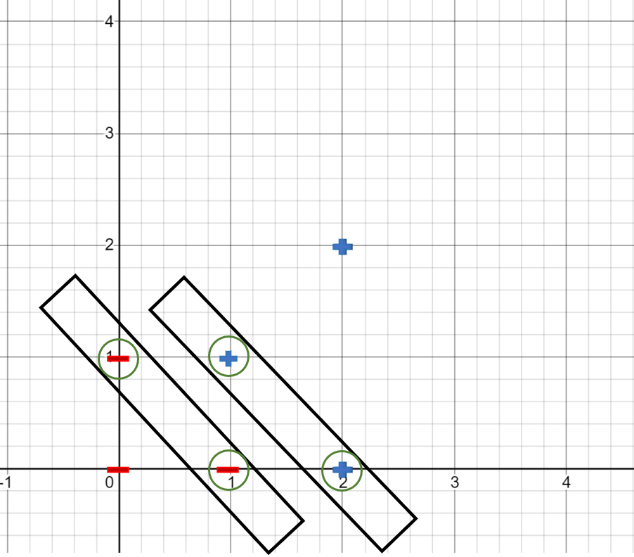

(3)

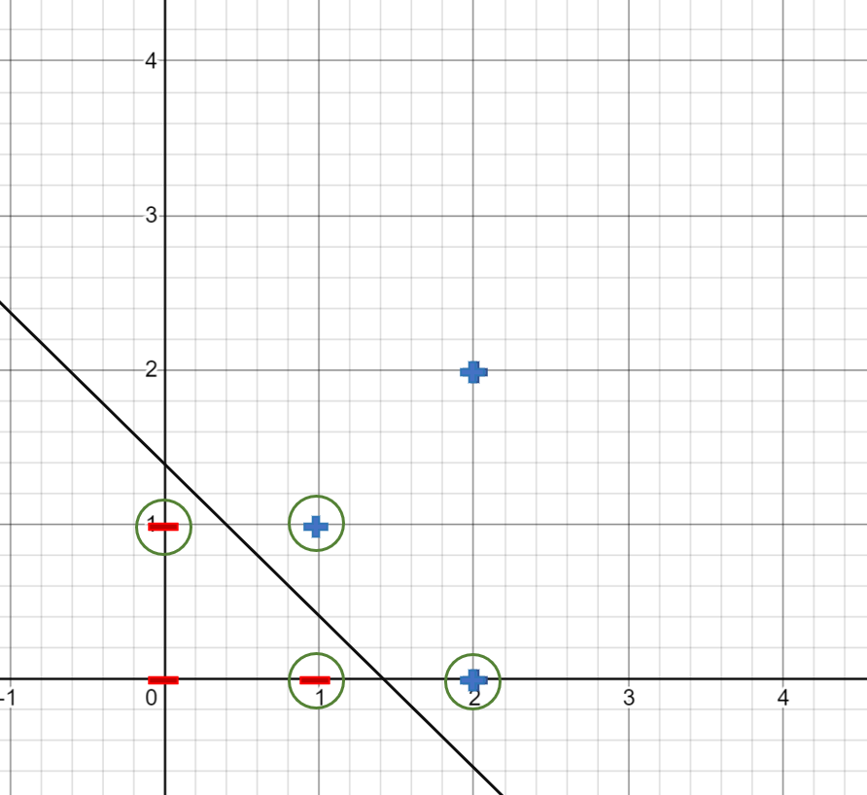

(d)

In the vectors, we select the point1: (1, 0), point3: (1, 1) and point5: (2, 0), and we can the three functions: $\left\{\begin{aligned}1*W_{1}+0*W_{2}+b=-1 \\ 1*W_{1}+1*W_{2}+b=1 \\ 2*W_{1}+0*W_{2}+b=1\end{aligned}\right.$, there are three unknowns and three the equations, so we can get all results: $W_{1}=2, W_{2}=2, b=-3$. So, the optional separating hyperplane of this system is: $2x_{1}+{2x}_{2}-3=0$, the bias is -3.

The margin for each point:

$-$ For $P_{1}\left(1, 1\right):$ $d_{1}=\frac{\left|2x_{1}+2x_{2}-3\right|}{\sqrt{2^{2}+2^{2}}}=\frac{\sqrt{2}}{4}$.

$-$ For $P_{2}\left(2, 2\right):$ $d_{2}=\frac{\left|2x_{1}+2x_{2}-3\right|}{\sqrt{2^{2}+2^{2}}}=\frac{5\sqrt{2}}{2}$.

$-$ For $P_{3}\left(2, 0\right):$ $d_{3}=\frac{\left|2x_{1}+2x_{2}-3\right|}{\sqrt{2^{2}+2^{2}}}=\frac{\sqrt{2}}{4}$.

$-$ For $P_{4}\left(0, 0\right):$ $d_{4}=\frac{\left|2x_{1}+2x_{2}-3\right|}{\sqrt{2^{2}+2^{2}}}=\frac{3\sqrt{2}}{4}$.

$-$ For $P_{5}\left(1, 0\right):$ $d_{5}=\frac{\left|2x_{1}+2x_{2}-3\right|}{\sqrt{2^{2}+2^{2}}}=\frac{\sqrt{2}}{4}$.

$-$ For $P_{6}\left(0, 1\right):$ $d_{6}=\frac{\left|2x_{1}+2x_{2}-3\right|}{\sqrt{2^{2}+2^{2}}}=\frac{\sqrt{2}}{4}$.

For the minimum margin $γ=2*\min_{0≤i≤6}\left(d_{i}\right)=2*\frac{\sqrt{2}}{4}=\frac{\sqrt{2}}{2}$.

Q2.

Jaccard coefficient: $JC=\frac{f_{11}}{f_{01}+f_{10}+f_{11}}$. We set $'yes'$ to 1 and $'No'$ to 0

Adopt Jaccard similarity to measure the closeness between samples:

$JC_{1}=\frac{2}{3}$ $JC_{2}=\frac{0}{2}=0$ $JC_{3}=\frac{1}{3}$ $JC_{4}=\frac{2}{4}=\frac{1}{2}$

$JC_{5}=\frac{2}{3}$ $JC_{6}=\frac{1}{4}$ $JC_{7}=\frac{2}{4}=\frac{1}{2}$ $JC_{8}=\frac{2}{3}$

With $k value$ set to 5:

The largest five Jaccard similarity is $JC_{1}, JC_{5},JC_{8},JC_{4},JC_{7}$.

Then for their classes:

$1-Mammals$

$4-Mammals$

$5-Non$- $Mammals$

$7-Mammals$

$8-Mammals$

There are 4 Mammals and 1 Non-mammals, so classify the test to Mammals.

(b)

We have to compute $Gain(D,A)$ for each attribute A. First of all, calculate the entropy for the category.

$- I\left(D\right)=-\frac{4}{8}*\log\left(\frac{4}{8}\right)-\frac{4}{8}*\log\left(\frac{4}{8}\right)=1$

Then focus on $A=Give Birth$

$- I\left(D_{yes}\right)=-\frac{4}{4}*\log\left(\frac{4}{4}\right)-\frac{0}{4}*\log\left(\frac{0}{4}\right)=0$

$- I\left(D_{No}\right)=-\frac{4}{4}*\log\left(\frac{4}{4}\right)-\frac{0}{4}*\log\left(\frac{0}{4}\right)=0$

$- Weight average=\frac{1}{2}*I\left(D_{yes}\right)+\frac{1}{2}*\left(D_{No}\right)=0$

$- Gain\left(D_{Give Birth}\right)=I\left(D\right)- Weight average=1$

Then focus on $A=Can Fly$

$- I\left(D_{yes}\right)=-\frac{2}{3}*\log\left(\frac{2}{3}\right)-\frac{1}{3}*\log\left(\frac{1}{3}\right)=0.9183$

$- I\left(D_{No}\right)=-\frac{2}{5}*\log\left(\frac{2}{5}\right)-\frac{3}{5}*\log\left(\frac{3}{5}\right)=0.9710$

$- Weight average=\frac{3}{8}*I\left(D_{yes}\right)+\frac{5}{8}*I\left(D_{No}\right)=0.9512$

$- Gain\left(D_{Can Fly}\right)=I\left(D\right)- Weight average=0.0488$

Then focus on $A= Live in Water$

$- I\left(D_{yes}\right)=-\frac{2}{3}*\log\left(\frac{2}{3}\right)-\frac{1}{3}*\log\left(\frac{1}{3}\right)=0.9183$

$- I\left(D_{No}\right)=-\frac{2}{5}*\log\left(\frac{2}{5}\right)-\frac{3}{5}*\log\left(\frac{3}{5}\right)=0.9710$

$- Weight average=\frac{3}{8}*I\left(D_{yes}\right)+\frac{5}{8}*I\left(D_{No}\right)=0.9512$

$- Gain\left(D_{Live in Water}\right)=I\left(D\right)- Weight average=0.0488$

Then focus on $A= Have Legs$

$- I\left(D_{yes}\right)=-\frac{2}{5}*\log\left(\frac{2}{5}\right)-\frac{3}{5}*\log\left(\frac{3}{5}\right)=0.9710$

$- I\left(D_{No}\right)=-\frac{2}{3}*\log\left(\frac{2}{3}\right)-\frac{1}{3}*\log\left(\frac{1}{3}\right)=0.9183$

$- Weight average=\frac{5}{8}*I\left(D_{yes}\right)+\frac{3}{8}*I\left(D_{No}\right)=0.9512$

$- Gain\left(D_{Have Legs}\right)=I\left(D\right)- Weight average=0.0488$

$Gain\left(D_{Give Birth}\right)>Gain\left(D_{Have Legs}\right)≥Gain\left(D_{Can Fly}\right)> Gain\left(D_{Live in Water}\right)$

So, split using the attribute $Give Birth$.

Give Birth

***Yes***

***No***

Mammals Non-Mammals

It can get the result and it not need to split again.

The Give birth of the test one is $'Yes'$, so classify the test to Mammals.

Set the set is split on an attribution A into subset yes and no

Gini index:

$gini\left(D\right)=1-{\sum_{i}^{m}{p_{i}}}^{2}=1-{\left(\frac{1}{2}\right)}^{2}-{\left(\frac{1}{2}\right)}^{2}=\frac{1}{2}$

Focus on $Give Birth$:

$gini\left(D_{Yes}\right)=1-{\left(\frac{4}{4}\right)}^{2}-{\left(\frac{0}{4}\right)}^{2}=0$

$gini\left(D_{No}\right)=1-{\left(\frac{4}{4}\right)}^{2}-{\left(\frac{0}{4}\right)}^{2}=0$

$gini_{Give Birth}\left(D\right)=\frac{\left|D_{yes}\right|}{\left|D\right|}*gini\left(D_{yes}\right)+\frac{\left|D_{No}\right|}{\left|D\right|}*gini\left(D_{No}\right)=0+0=0$

$Δgini\left(Give Birth\right)=gini\left(D\right)-gini_{Give Birth}\left(D\right)=\frac{1}{2}-0=\frac{1}{2}$

Focus on $Can Fly$:

$gini\left(D_{Yes}\right)=1-{\left(\frac{2}{3}\right)}^{2}-{\left(\frac{1}{3}\right)}^{2}≈0.4444$

$gini\left(D_{No}\right)=1-{\left(\frac{3}{5}\right)}^{2}-{\left(\frac{2}{5}\right)}^{2}=0.48$

$gini_{Can Fly}\left(D\right)=\frac{\left|D_{yes}\right|}{\left|D\right|}*gini\left(D_{yes}\right)+\frac{\left|D_{No}\right|}{\left|D\right|}*gini\left(D_{No}\right)=\frac{3}{8}*0.4444+\frac{5}{8}*0.48=0.46665$

$Δgini\left(Can Fly\right)=gini\left(D\right)-gini_{Can Fly}\left(D\right)=\frac{1}{2}-0.46665=0.03335$

Focus on $Can Fly$:

$gini\left(D_{Yes}\right)=1-{\left(\frac{2}{3}\right)}^{2}-{\left(\frac{1}{3}\right)}^{2}≈0.4444$

$gini\left(D_{No}\right)=1-{\left(\frac{3}{5}\right)}^{2}-{\left(\frac{2}{5}\right)}^{2}=0.48$

$gini_{Can Fly}\left(D\right)=\frac{\left|D_{yes}\right|}{\left|D\right|}*gini\left(D_{yes}\right)+\frac{\left|D_{No}\right|}{\left|D\right|}*gini\left(D_{No}\right)=\frac{3}{8}*0.4444+\frac{5}{8}*0.48=0.46665$

$Δgini\left(Can Fly\right)=gini\left(D\right)-gini_{Can Fly}\left(D\right)=\frac{1}{2}-0.46665=0.03335$

Focus on $Live in Water$:

$gini\left(D_{Yes}\right)=1-{\left(\frac{2}{3}\right)}^{2}-{\left(\frac{1}{3}\right)}^{2}≈0.4444$

$gini\left(D_{No}\right)=1-{\left(\frac{3}{5}\right)}^{2}-{\left(\frac{2}{5}\right)}^{2}=0.48$

$gini_{Live in Water}\left(D\right)=\frac{\left|D_{yes}\right|}{\left|D\right|}*gini\left(D_{yes}\right)+\frac{\left|D_{No}\right|}{\left|D\right|}*gini\left(D_{No}\right)=\frac{3}{8}*0.4444+\frac{5}{8}*0.48=0.46665$

$Δgini\left(Live in Water\right)=gini\left(D\right)-gini_{Live in Water}\left(D\right)=\frac{1}{2}-0.46665=0.03335$

Focus on $Have Legs$:

$gini\left(D_{Yes}\right)=1-{\left(\frac{3}{5}\right)}^{2}-{\left(\frac{2}{5}\right)}^{2}=0.48$

$gini\left(D_{No}\right)=1-{\left(\frac{2}{3}\right)}^{2}-{\left(\frac{1}{3}\right)}^{2}≈0.4444$

$gini_{Have Legs}\left(D\right)=\frac{\left|D_{yes}\right|}{\left|D\right|}*gini\left(D_{yes}\right)+\frac{\left|D_{No}\right|}{\left|D\right|}*gini\left(D_{No}\right)=\frac{5}{8}*0.48+\frac{3}{8}*0.4444=0.46665$

$Δgini\left(Have Legs\right)=gini\left(D\right)-gini_{Have Legs}\left(D\right)=\frac{1}{2}-0.46665=0.03335$

(c)

Firstly, we compute the prior probability for each class:

Set $C_{1}='Mammals'$, $C_{2}=^{'}Non$- $Mammals^{'}$

$- P\left(C_{1}\right)=\frac{4}{8}=0.5$, $P\left(C_{2}\right)=\frac{4}{8}=0.5$

To derive $P\left(x|C_{i}\right)$ for $i=1,2$, we need to compute the following:

$- P\left(Give Birth=Yes | C_{1}\right)=\frac{4+1}{4+2}=\frac{5}{6}$, $P\left(Give Birth=Yes | C_{2}\right)=\frac{0+1}{4+2}=\frac{1}{6}$

$- P\left(Can Fly=No | C_{1}\right)=\frac{2+1}{4+2}=\frac{1}{2}$, $P\left(Can Fly=No | C_{2}\right)=\frac{3+1}{4+2}=\frac{2}{3}$

$- P\left(Live in Water=Yes | C_{1}\right)=\frac{1+1}{4+2}=\frac{1}{3}$, $P\left(Live in Water=Yes | C_{2}\right)=\frac{2+1}{4+2}=\frac{1}{2}$

$- P\left(Have Legs=yes | C_{1}\right)=\frac{3+1}{4+2}=\frac{2}{3}$, $P\left(Have Legs=Yes | C_{2}\right)=\frac{2+1}{4+2}=\frac{1}{2}$

Given the previous probabilities, we obtain:

$- P\left(x | C_{1}\right)=P\left(GiveBirth=Yes | C_{1}\right)*P\left(CanFly=No | C_{1}\right)* P\left(Livein Water=Yes | C_{1}\right)*P\left(Have Legs=yes | C_{1}\right)=\frac{5}{6}*\frac{1}{2}*\frac{1}{3}*\frac{2}{3}*\frac{1}{2}≈0.0462965$

$- P\left(x | C_{2}\right)=P\left(GiveBirth=Yes | C_{2}\right)*P\left(CanFly=No | C_{2}\right)* P\left(Livein Water=Yes | C_{2}\right)*P\left(HaveLegs=yes | C_{2}\right)=\frac{1}{6}*\frac{2}{3}*\frac{1}{2}*\frac{1}{2}*\frac{1}{2}=0.013889$

$P\left(x | C_{1}\right)>P\left(x | C_{2}\right)$, $so$ classify the test to ($C_{1}$) Mammals.

Q3.

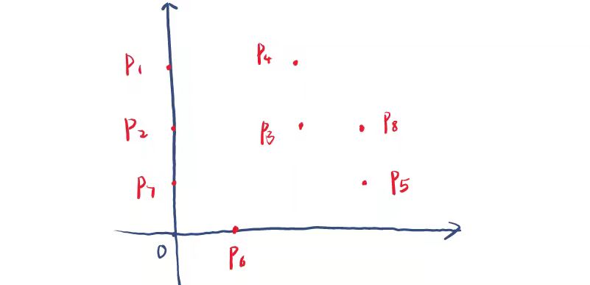

The eight points in the coordinate system like above picture:

Firstly, we can calculate the Euclidean distance for each point:

For point $P_{1}:$ $dis\left(1,2\right)=1$, $dis\left(1,3\right)=\sqrt{5}$, $dis\left(1,4\right)=3$, $dis\left(1,5\right)=\sqrt{13}$, $dis\left(1,6\right)=\sqrt{10}$, $dis\left(1,7\right)=2$, $dis\left(1,8\right)=\sqrt{10}$.

For point $P_{2}:dis\left(2,3\right)=2$, $dis\left(2,4\right)=\sqrt{5}$, $dis\left(2,5\right)=\sqrt{10}$, $dis\left(2,6\right)=\sqrt{5}$, $dis\left(2,7\right)=1$, $dis\left(2,8\right)=3$.

For point $P_{3}:dis\left(3,4\right)=1$, $dis\left(3, 5\right)=\sqrt{2}$, $dis\left(3, 6\right)=\sqrt{5}$, $dis\left(3,7\right)=\sqrt{5}$, $dis\left(3,8\right)=1$.

For point $P_{4}:dis\left(4,5\right)=5$, $dis\left(4, 6\right)=\sqrt{10}$, $dis\left(4, 7\right)=2\sqrt{2}$, $dis\left(4, 8\right)=\sqrt{2}$.

For point $P_{5}:dis\left(5, 6\right)=\sqrt{5}$, $dis\left(5, 7\right)=\sqrt{3}$, $dis\left(5, 8\right)=1$.

For point $P_{6}:dis\left(6, 7\right)=\sqrt{2}$, $dis\left(6, 8\right)=2\sqrt{2}$.

For point $P_{7}:dis\left(7, 8\right)=\sqrt{10}$.

$ϵ=1$ and $minPt=3$. For each point, select the other points which distance is smaller $ϵ$

$- N\left(P_{1}\right)=\{P_{1}, P_{2}\}$

$- N\left(P_{2}\right)=\{P_{1}, P_{2},P_{7}\}$

$- N\left(P_{3}\right)=\{P_{3}, P_{4},P_{8}\}$

$- N\left(P_{4}\right)=\{P_{3}, P_{4}\}$

$- N\left(P_{5}\right)=\{P_{5}, P_{8}\}$

$- N\left(P_{6}\right)=\{P_{6}\}$

$- N\left(P_{7}\right)=\{P_{2},P_{7}\}$

$- N\left(P_{8}\right)=\{P_{3}, P_{5},P_{8}\}$

As $MinPt=3$

$- P_{2}, P_{3},P_{8}$ are core points

$- P_{1}, P_{4},P_{5},P_{7}$ are border points

$- P_{6}$ is a noise point

Now run DBSCAN algorithm:

For each visited points, support start with $P_{2}$ ( $P_{2}$ is a core point and a cluster is form $C_{1}$), then mark $P_{1}$ as the visited and retrieve $ϵ$- $neighborhood$, $N\left(P_{2}\right)=\{P_{1}, P_{2},P_{7}\}$

* Next add $P_{1}$ (visited), as $N\left(P_{1}\right)=\left\{P_{1},P_{2}\right\}$, no append.
* Next add $P_{7}$ (visited), as $N\left(P_{7}\right)=\{P_{2}, P_{7}\}$, no append.
* Finish for $C_{1}=\{P_{1},P_{2},P_{7}\}$

Now $\left\{P_{1},P_{2},P_{7}\right\}$ are visited

For each unvisited point, suppose continue with $P_{3}$ ( $P_{2}$ is a core point and a cluster is form $C_{2}$).

mark $P_{3}$ as the visited and retrieve $ϵ$- $neighborhood$, $N\left(P_{3}\right)=\{P_{3}, P_{4},P_{8}\}$

* Next add $P_{4}$ (visited), as $N\left(P_{4}\right)=\left\{P_{3},P_{4}\right\}$, no append.
* Next add $P_{8}$ (visited), as $N\left(P_{8}\right)=\{P_{3}, P_{5}, P_{8}\}$, append $N\left(P_{5}\right)$ to $N(P_{3})$.
* Next add $P_{5}$ (visited), as $N\left(P_{5}\right)=\{P_{5},P_{8}\}$, no append.
* Finish for $C_{2}=\{P_{3}, P_{4},P_{5}, P_{8}\}$

Now $\left\{P_{1},P_{2},P_{3}, P_{4},P_{5}, P_{7},P_{8}\right\}$ are visited.

For each unvisited point, suppose continue with $P_{6}$.

mark $P_{1}$ as the visited and retrieve $ϵ$- $neighborhood$, $N\left(P_{6}\right)=\{P_{6}\}$.

* $P_{6}$ is not a core point, mark the $P_{6}$ as noise point $.$

All points are visited:

$- C_{1}=\{P_{1},P_{2},P_{7}\}$

$- C_{2}=\{P_{3}, P_{4},P_{5}, P_{8}\}$

$- Noise=\{P_{6}\}$